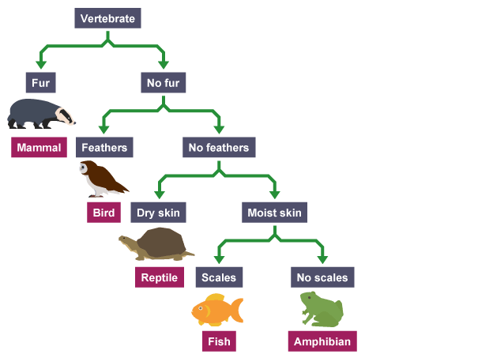***Year 7 Classification Test Revision***

1. Look at the dichotomous key for Vertebrates.
   1. What features are used to separate the organisms?
   2. What features does a bird have?
   3. What features does a fish have?
2. Draw a branched dichotomous key for these animals.

* Rabbit
* Dog
* Cat
* Fish
* Guinea pig
* Bird
* Mouse
* Horse

1. Write a tabular key for the branched key you drew in question 2.
2. What are the three kingdoms of living things we have learnt about? Name two common features of organisms in each group.
3. Redraw, extend and complete the table to show the nine phyla we have learnt about in Kingdom Animalia.

|  |  |  |
| --- | --- | --- |
| **Phylum** | **Characteristics** | **Example** |
| Chordates | Have a spinal cord and backbone. | Monkey |
|  |  |  |

1. 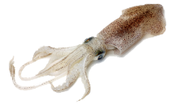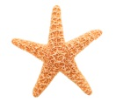For each of the animals below, name its phylum and explain your choice.
   * Starfish

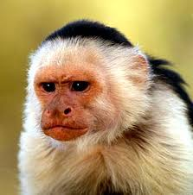

* + Monkey

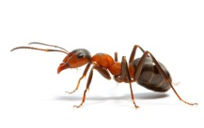

* + Ant

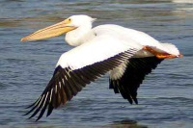

* + Pelican
  + 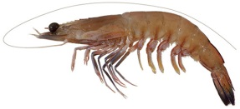Prawn

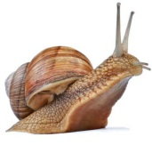

* + Snail
  + Squid

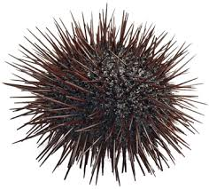

* + Sea urchin
  + 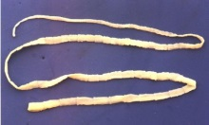Tape worm
  + 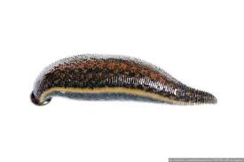Leech

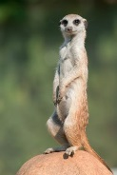

* + Meerkat

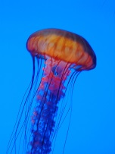

* + Jellyfish

1. Redraw, extend and complete the table to show the 5 classes of chordates.

|  |  |  |
| --- | --- | --- |
| **Class** | **Characteristics** | **Example** |
|  |  |  |

1. For each of the chordates below, name its class and explain your choice.
   * 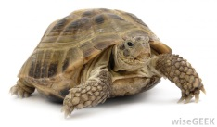Turtle
   * 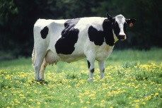Cow
   * 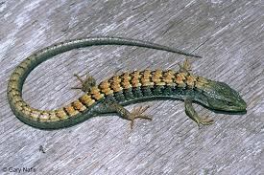Lizard

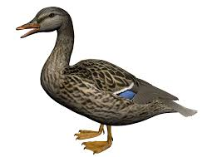

* + Duck
  + 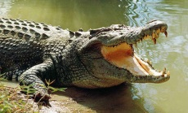Crocodile

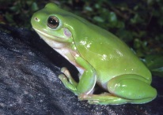

* + Tree Frog

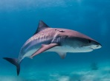

* + Shark

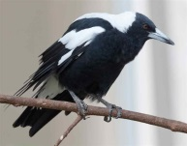

* + Magpie
  + 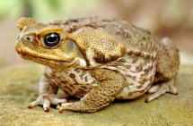Cane toad
  + 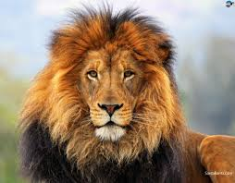Lion
  + 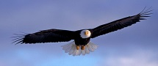Eagle

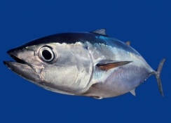

* + Tuna

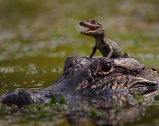

* + Alligator

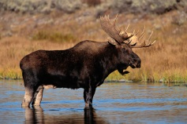

* + Moose
  + 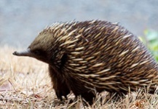Echidna

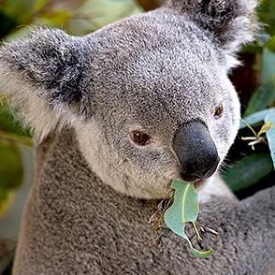

* + Koala

1. Redraw, extend and complete the table to show the 4 classes of arthropods.

|  |  |  |
| --- | --- | --- |
| **Class** | **Characteristics** | **Example** |
|  |  |  |

1. For each of the arthropods below, name its class and explain your choice.
   * 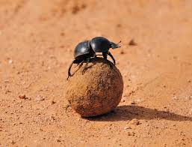Dung beetle
   * Spider

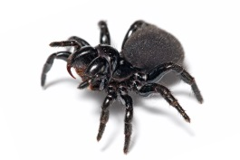

* + 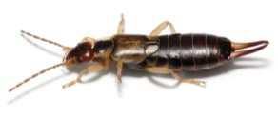Earwig

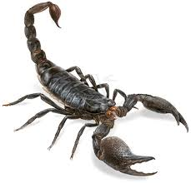

* + Scorpion
  + 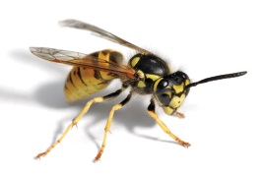Wasp
  + 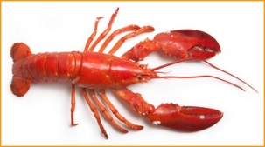Lobster
  + 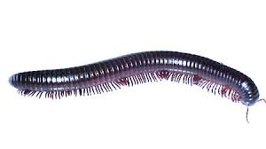Millipede

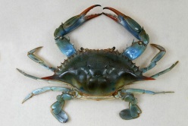

* + Crab
  + 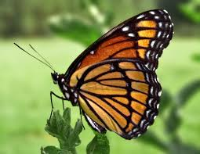Butterfly
  + 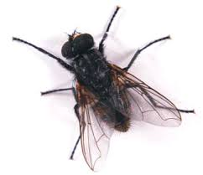Fly